**Client Site GPS**

**Setting Client Site Address and GPS (an example)**

1. Select Client Type - Automotive
2. Client Site - Nunawading Hyundai
3. Stary type in the address, the google suggestions will show and choose the correct address from the suggestions
   1. For e.g. start type “434 Whitehorse” and select address from autocomplete field as “434 Whitehorse Road, Nunawading VIC, Australia”
   2. This will auto populate Client GPS

4. Save client settings by clicking Update button

5. Click on the link in GPS field to see the google map

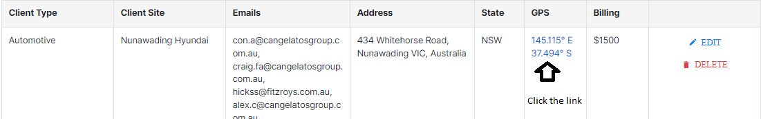

6. Google map will open in new tab as below

**IR Report**

1. Select Client Type: Automotive

2. Client Site: Nunawading Hyundai

1. Click on GPS map Link button to open the map

1. The map will be inserted in the PDF report

